**Alekhya Krishna Balivada Python Day 7 Assessment-7(19-12-2023)**

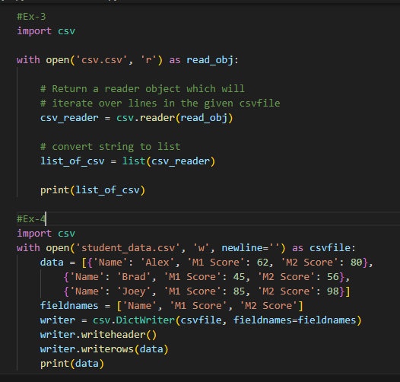**CSV:** It stands for ‘Comma Separated Values’. It is the simplest form of storing data in tabular form as plain text.

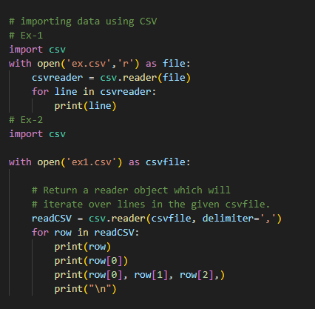

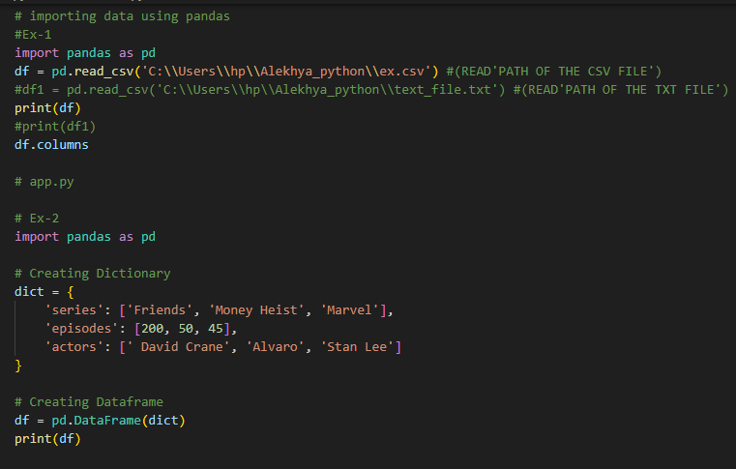**PANDAS:** Pandas is a python package providing fast, flexible and expressive data structures designed to make working with labeled data both easy and intuitive.